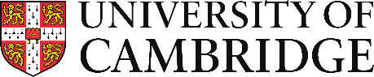

COVID-19 Impact Assessment Form: Staff Review and Development (SRD)
We recognise that COVID-19 has had a significant impact on the HEI sector and many staff will have faced difficulties in carrying out their usual duties, preventing them from progressing as usual. We welcome a voluntary statement detailing the impact on your work, including the completion of your objectives, which will be taken into account when discussing your progress with your manager at your SRD meeting. You may include reference to personal matters which have affected your work if you wish, however there is no requirement to do so, nor are you required to disclose if you were furloughed.

Name:
Institution: |  | Role:

Please set out below details of the impact of COVID-19 on your achievements and/or ability to carry out your usual duties during this time and your assessment of the impact on your future work.
This statement should not exceed 1,000 words.

Signed:
(Electronic signature acceptable)
Date:

Once completed, please add this form to the other documentation that you have completed in relation to your SRD.

