CCWS Worker FAQ’s

Worker Profile on CCWS

Q. I’m having technical issues with my CCWS account. Who do I contact?
A. Please email CHRIS.helpdesk@admin.cam.ac.uk and a member of the systems helpdesk team will assist as soon as possible.

Q Why can’t my department view the profile I have completed?
A Please ensure you have clicked the “submit for approval” button at the top of the page, this will appear when all non-mandated tiles in your profile have moved from red to green. You should also receive an email confirming your profile has been submitted.

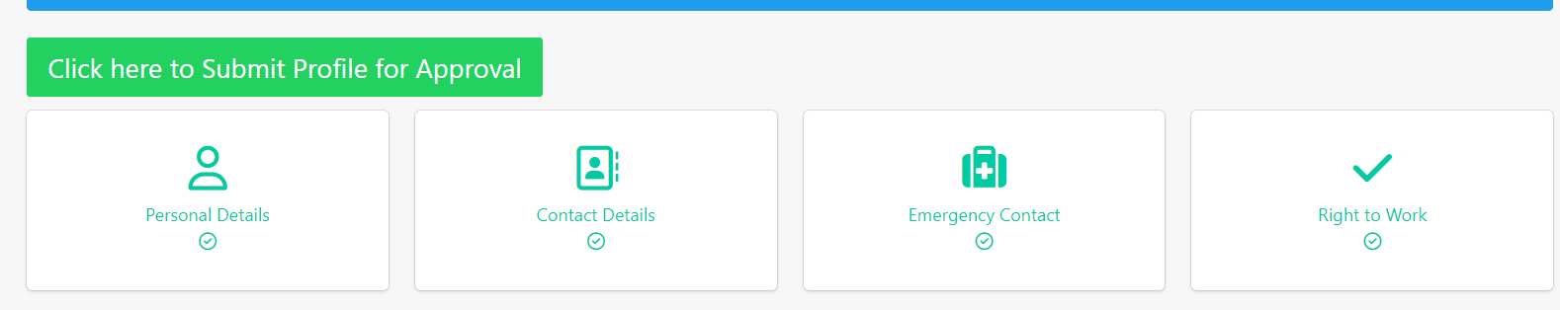

Q: I’m a UK National and have the right to work - do I need to show you my documents?
A: Yes. As an employer we must follow UK legislation which requires us to verify ALL workers’ right to work. This includes UK Nationals, EU and International workers. It is a criminal offence to engage a worker who does not have the right to work in the UK. The law requires us to verify all workers’ right to work in the UK before they start work, by checking and retaining copies of certain documents. This requirement applies to ALL workers, irrespective of their nationality and the type or length of the engagement.

Q: As a casual worker do I have to register every time I start a new job?
A: No, once you have registered and your profile has been approved you are able to undertake work for any area of the University.

Q: I am unable to log in and get an error message?

A If you receive the error message shown on the left (picture below), this means your account has been temporarily deactivated. This is usually because you haven’t worked for 12 weeks and had no future bookings in CCWS. In this situation we are required to inform the pension regulator and deactivate your profile until you receive your next booking.

If you have been invited to work again please contact your main department of work who will reactivate your profile for you. There is no need for you to complete all your details again, as your profile will still be there, but you will have to confirm your tax status. There is the option to upload a P45 if you have one.

If you have received an error message similar to the one on the right, this is due to a password/username error.

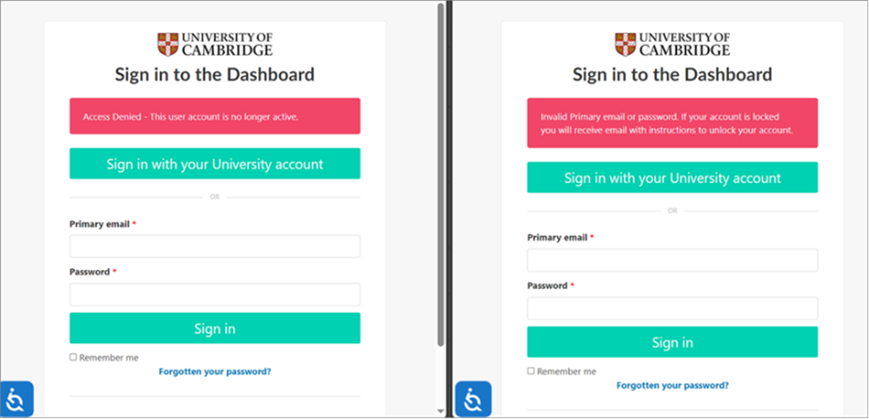

Q: What do I need to do if I need to cancel a booking I have already accepted?
A: Please contact the department who have offered you the booking.

Timesheet/Payroll Queries

Q: When should I expect to be paid?
The deadline for submitting your timesheet and the pay date for each month are available on the Finance website

We recommend submitting your claims as soon as possible after working. Delays leading to large claims in a single month may result in you paying higher National Insurance contributions.

Q: How do I submit a timesheet?
Please go to the “to submit” area of your “timesheets” menu where you will see the timesheets ready to be submitted. There are various training guides to help you to complete a timesheet, edit a timesheet and add expenses (if applicable) in training library

Q: I realised I made an error on my timesheet after submission. Who should I contact to have it corrected?
A: Please contact the department you did the work for in the first instance, they can then escalate this to the Casual Worker Team or Payroll Team if the timesheet has already been approved.

Q: I have incorrectly submitted a timesheet and need it deleted, who should I contact?
A: Please contact the department you did the work for in the first instance, they can then escalate this to the Casual Worker Team or Payroll Team if the timesheet has already been approved.

Q. I forgot to submit my expenses form with my timesheet. What do I need to do?
A. We do have a process to pay late expense claims, this process needs to be instigated by the department you did the work for, please contact them in the first instance.

Q. Do I need to submit a weekly timesheet even if I'm on a direct booking with fixed hours?
A. Yes. A timesheet will be automatically created to match every fixed hours booking. If there are no changes you will just need to select ‘to submit’ to send for approval. However, you do have the option to edit the timesheet (if you have worked extra hours for example) before you submit it.

Q. What if I forget to submit a timesheet?
A. You will receive reminders from the system once a month if you have any timesheets to be submitted. We ask that you submit your timesheets in a timely manner.

Q: What is a National Insurance (NI) number – why do I need one?
A: This number makes sure there is a record of the National Insurance contributions and Income Tax you pay in the UK. It is also a reference number for the entire social security system and each number is unique and is made up of letters and numbers e.g. QQ123456A. Your national insurance number never changes even if you go abroad, marry, register as a civil partner or change your name. The University needs this so that we can organise your tax and contributions at the correct rates through our payroll system.

Q: Do I receive holiday pay?
A: Yes; you will receive holiday pay at a rate of 12.07% of every hour worked on each assignment booked via CCWS. This will be displayed on your payslip.

Q: What if I don't have a UK bank account?
A: The University is required to pay into your bank account, payments cannot be made into someone else's account (e.g., friend or family member). All casual workers are expected to have a UK bank account. However, where (by exception) you do not have a UK bank account, your International Bank Details should be added to your profile: this will be flagged to Payroll (as it will be identified as a non-UK bank account).

Q: What if I change my bank account or address?
A: You can update your details through your CCWS account. Some of the tiles cannot be updated once your worker profile has been updated, so if you receive this message, please contact your department who will temporarily “reject” your profile, meaning it is returned to you in an editable state, you then need to resubmit your profile for approval.

Q. Do I need to submit a P45 for each assignment?
If you have a P45 please upload this into the system when you register. A P45 can also be added to your worker profile at a later date.

Q. Will I be issued with a P45 at the end of each assignment?
You should be issued with a P45 when you have completed all of your assignments and are flagged as a “leaver” on CCWS. This will also happen if you have not done any work for 12 weeks, or been booked for any future work at the University, due to auto-enrolment regulations. Your profile can be reactivated if you return to complete further work.

Q: Will my timesheet be submitted in advance of the hours being worked?
A: No, there is no mechanism in CCWS to allow you to claim for work that has not yet occurred.

Q: I haven’t got the facilities to scan my receipts for expenses claims and don’t have a smartphone or other device to take a photo of them.
A: Please contact the department you did the work for - they may be able to scan the receipts for you and return the images for you to use when completing the form.

Q: I have a query about my Tax / NI deduction. Who should I contact?
A: Please contact the Payroll team at payroll.enquiries@admin.cam.ac.uk

Q. I have been receiving emails about auto-enrolment, are these spam?
If you are engaged through the University’s Temporary Employment Service (TES), are a Playworker or have a ‘worker’ agreement with the University, you are eligible for the University’s auto-enrolment pension scheme, the Universities and Colleges Retirement Savings Scheme (UCRSS).
Aviva administers the scheme on behalf of Mercer. You can find out more information within the UCRSS member guide, https://library.aviva.com/ngs500h2.pdf.
Aviva will email you details about the scheme and what to do should you not wish to be enrolled. Some emails may require you to take action. Please do not dismiss them as spam

