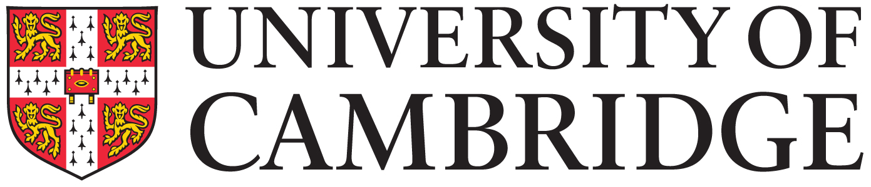
Employee name

Performance Improvement Plan
Target area  Detail specific area where performance standards have not been met | Performance concern  Detail specific dates and examples of where the standards have not been met | Expected standard of performance  Detail what is expected of the employee in terms of their performance i.e. what does ‘good’ look like | Agreed improvement actions  Detail what actions need to be taken to meet expected standard of performance | Support  Detail what has been agreed in terms of support required to achieve the expected standard of performance |  | Review Date | Review notes  Detail improvement made and any future review dates | Date to achieve expected standard

This action plan has been agreed by: | Signed | Date
Manager
Employee

